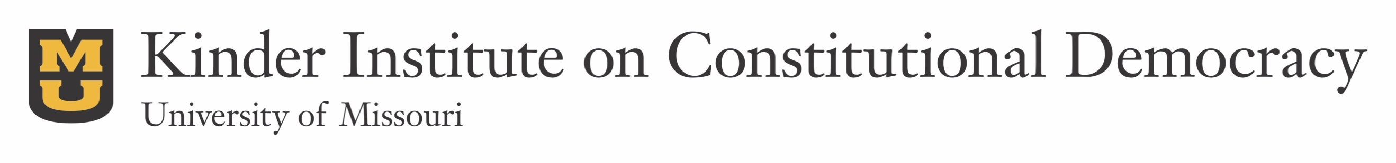

The Kinder Institute was pleased to support the scholarly work of the following MU faculty and graduate students during the Fall 2016 award cycle for our ongoing program of research and travel grants.

Faculty

- Jay Dow (Political Science): To support archival research for his current book project, which explores the history of elections in the early American republic
- Harrison Kim (History): To support travel for his research into approaches to examining the democratic foundations of the North Korean government
- Lee Manion (English): To support June 2017 research at Harvard’s Houghton Library for his in-progress book manuscript, The King is Emperor: Sovereignty, Justice, and Theories of Empire in Pre-Modern Literature
- Abigail Manzella (English): To support research at the University of Illinois’ Gwendolyn Brooks archives for an article project on the politics of Brooks’ Maud Martha
- Bryce Reeder (Political Science): To support field interviews for a current research project on the relationship between political beliefs and military service and its implications for democratic processes

Graduate Students

- Jessica Anderson (Political Science): To support travel to the February 2017 annual meeting of the International Studies Association
- Brandon Flint (History): To support research at the National Archives in College Park for his dissertation, God in This New World of Tomorrow: The Rise of Protestant Short-Term Missions
- Ed Goldring (Political Science): To support Summer 2017 travel to Seoul to conduct research for his dissertation on the use of U.S. aid in North Korea
- Michael Hendricks (Political Science): To support travel over winter break to Nicaragua to conduct field research on the influence of foreign infrastructure investments on democratic processes and institutions in the developing world
- Joel Reed and Josh Bramlett (Political Communication): To support data collection for their joint research project, “A Comparative Functional Analysis of Campaign Communication in Partisan and Non-Partisan Elections”
- Sean Rost (History): To support travel to the October 2016 annual meeting of the Western History Association

