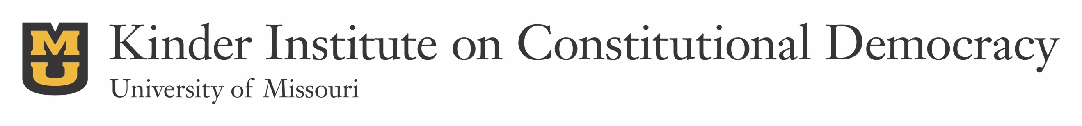
November 7, 2017

Call for Applications:
Spring 2018 Research and Travel Grants

The Kinder Institute on Constitutional Democracy is pleased to continue its competitive program of research and travel grants for faculty and graduate students across all disciplines at the University of Missouri whose work overlaps with the Kinder Institute’s core goal of promoting teaching and scholarship on American political thought, history, and institutions, with a particular emphasis on the ideas and events of the American founding and their continued global impact and relevance today. Grants of up to $3,500 will be awarded for expenses related to research—including travel to archives, library purchases, research assistance, and data collection—and grants of up to $500 will be awarded for conference travel.

In addition to a current C.V., applicants should submit a proposal of no more than three pages that explains their research project and how it relates to the Kinder Institute’s scholarly mission. Proposals should also contain an explanation of the need for requested funds and a budget detailing how any money received from the Kinder Institute will be spent. For conference travel, applicants should include information about the conference or workshop and a statement about the nature of their participation. Graduate student applicants will also need to obtain a letter from their advisor affirming the need for funds and endorsing the application. All application materials should be sent to Kinder Institute Communications Associate Thomas Kane, KaneTC@missouri.edu, by Wednesday, March 14, 2017, at 5:00 PM. Applicants will be notified of their status within a month of the deadline, if not sooner.

Resources for research and travel grants are limited, so not all qualified applications will be accepted or fully funded. The Kinder Institute Joint Executive Committee will make all final award decisions.

For questions, please contact:

Kinder Institute Director Justin Dyer (DyerJB@missouri.edu) or Associate Director Jeff Pasley (PasleyJ@missouri.edu)

Note: Should your project receive funding, the Kinder Institute will contact you at the end of your grant period with instructions regarding completing an exit report. Consideration for future funding from the Kinder Institute is dependent on the timely submission of this report. Please see page 2 of this call for a list of additional application stipulations.

The following stipulations apply to all research and travel grant applications regardless of award cycle or available funds:

- We will consider only one proposal per applicant during each award cycle;
- Individuals who receive a research and travel award from the Kinder Institute may not re-apply for funding until the grant period for their current award has expired and the exit report for that award has been submitted;
- For ground travel, we will reimburse mileage according to the standard rate up to the cost of coach air travel between the destinations in question;
- In some cases, projects will be funded on the condition that research conducted as a result of the award is presented to Kinder Institute faculty and graduate students upon the grant period’s completion. Applicants to whom this condition applies are responsible for making arrangements for these presentations in a timely manner after the grant period has ended.

Any questions regarding these proposal stipulations can be directed to Kinder Institute Communications Associate Thomas Kane at KaneTC@missouri.edu.

